Blue Stars by Greg Latza Name_____________________________________________
Name of individual: __________________________________________________________________________________
Hometown: _______________________________________________________________________________________
Summarize his/her story: ____________________________________________________________________________ _________________________________________________________________________________________________ _________________________________________________________________________________________________
_________________________________________________________________________________________________
_________________________________________________________________________________________________
_________________________________________________________________________________________________
_________________________________________________________________________________________________
_________________________________________________________________________________________________
_________________________________________________________________________________________________
__________________________________________________________________________________________________
___________________________________________________________________________________________________ ________________________________________________________________________________________________ __________________________________________________________________________________________________
__________________________________________________________________________________________________
__________________________________________________________________________________________________
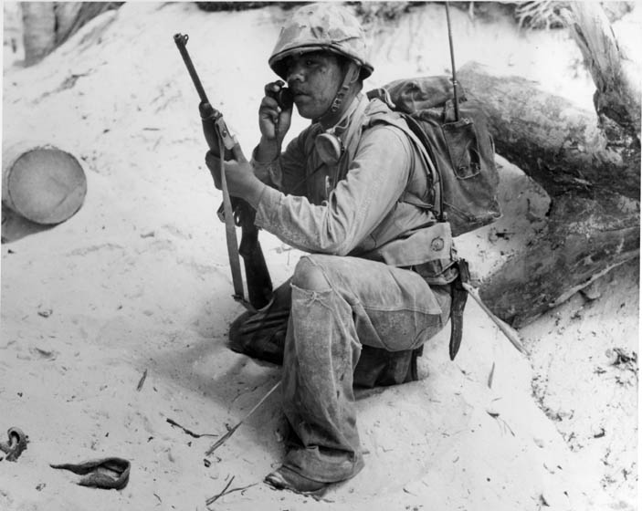
This person is interesting because __________________________________________________________________________________________________
___________________________________________________________________
_________________________________________________________________________________________________________________________________________________________________________________________________________ ___________________________________________________________________

