Children’s Book Play

Go to the library

Find a children’s book you can act out – roughly 5 minutes in length

You have days to work on it so I expect it be good…

You determine your own groups

Present your plays – a total of 100 points

Write a script with your group

Practice! Get creative! Find props, costumes, set, etc…

Rubric

_______ 25 point for the script

_______ 10 points for music within the play

_______ 15 points for everyone’s lines being memorized

_______15 points for costumes

_______ 15 points for props, set, design
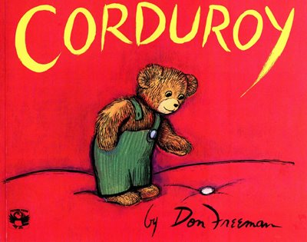
_______ 20 points for creativity and uniqueness

