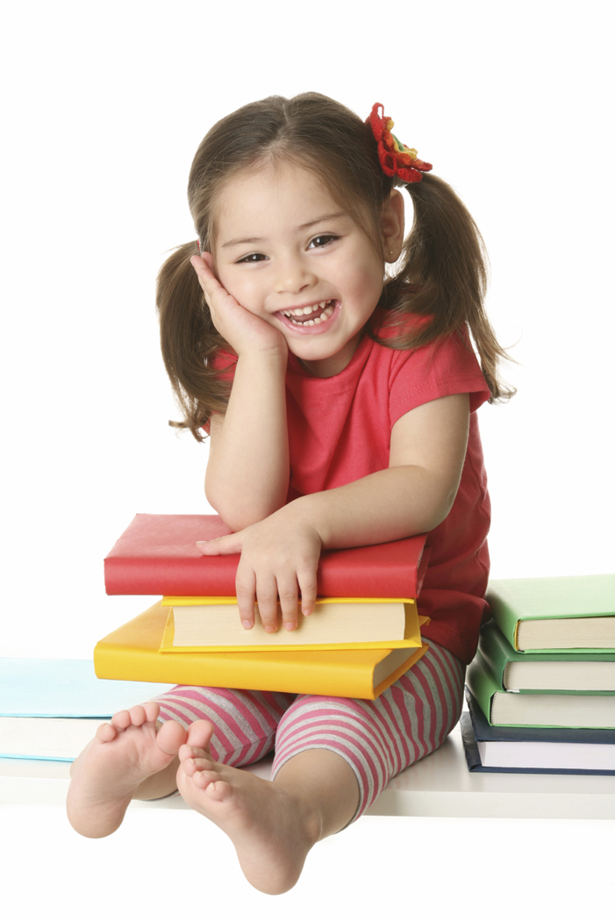
Children’s Book Unit

- You need to choose a children’s book that you really enjoy!
- It must be at least two minutes in length.

- The objective is to read with fluency and expression while making a little bit of eye contact now and then.
- We will be going in to the elementary classes to read the books to the kids.
- This requires you to practice!
- Before we go read for the elementary kids, you will be reading it to the Speech class as well.
- Things to think about:
  - Kids admire you – you’re older!
  - What types of books did you enjoy as a kid?
  - Pick something you like because you will be sick of it before the end.
  - Be very prepared – the kids expect you to read smoothly.
  - You will be graded on this!
  - The better you get at reading it, the faster it will go, so make sure to pick a book that is long enough.
  - Have fun with it. Let loose.

