Connector Role Sheet # _____

Name ________________

Write five ways you connect to the section of the book you just read. Not only do you put how you connect, but what happened in the book as well. You should either have a compound sentence or two sentences in order to completely what it expected.

1.________________________________________________________________________________

_________________________________________________________________________________

2._________________________________________________________________________________

__________________________________________________________________________________

3._________________________________________________________________________________

__________________________________________________________________________________

4._________________________________________________________________________________

___________________________________________________________________________________

5.________________________________________________________________________________
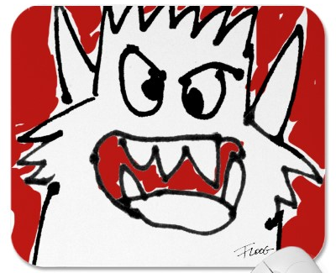
_______________________________________________

Things you can connect your book to:
Your family
Friends
School
Movies
Other books
Pets
Memories
Summer
Cars

