How much is that doggie…?
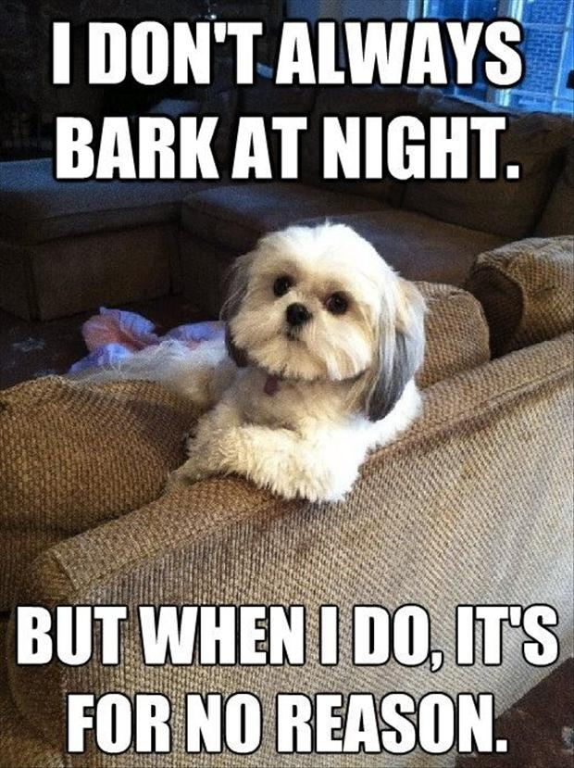

Items:
Dog
Bed
Shots
Kennel
License
Registration
Leash
Collar
Toys
Treats
Food
Bowls

Price:

TOTAL: _______________________________________

