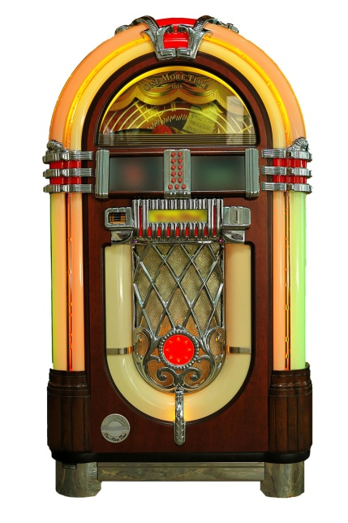
Lip Sync Unit
It’s pretty simple, honestly.
You will be put into groups.
With your group, you need to pick a song you can all agree on to lip sync for an audience.
Once you’ve chosen a song, let me know and I’ll get it to you so you can start practicing!
You will be given time in class to get ready to present!
You will be required to come up with costumes for your production – the costumes must represent the time period or song in some way.
You will also need to choreograph some movements for your song – no one wants to just watch you stand there and lip sync.
Choreography doesn’t require dancing, however, it can! – you could create a mini band, do a dance that every one knows (the electric slide) or any other movements that represent the song.
Things to keep in mind:
Pick a fun song!
Pick a song that most people would know!
Have fun with it!
Let loose. Be ready to step out of your comfort zone!

