Mask Unit
For this unit, you will draw from a hat to determine the type of mask you will create.
Venetian
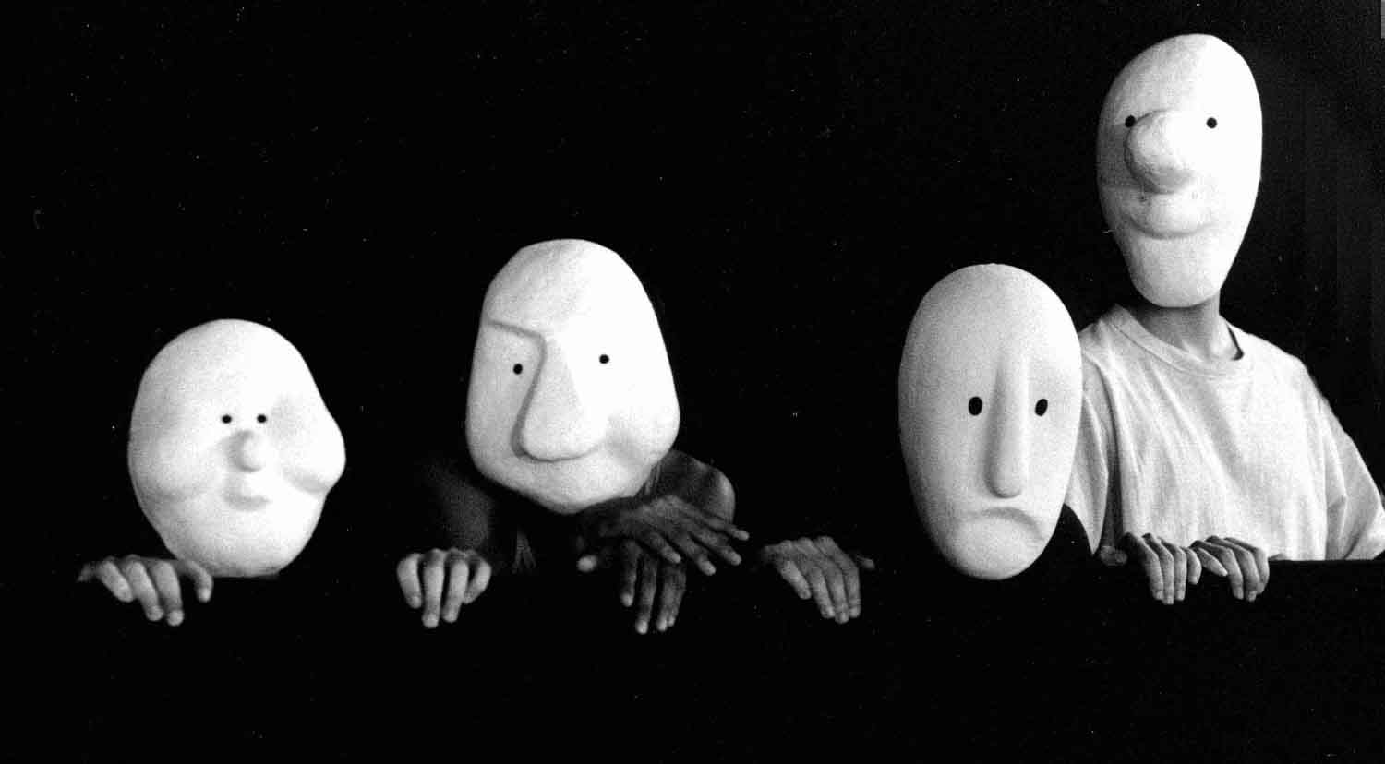
Greek
Inca
African
Chinese
Noh
Japanese
Basel
Commedia del’ arte

Once you have your type of mask, you will have to do some research to figure out what that type of mask looks like, why it looks that way, how to make it, etc.

Once your mask is finished, you will be doing a 2 minute presentation about it. You need to tell us about the history, the meaning of the colors, shapes, patterns, etc. Anything about the background of the mask, how they are used – whatever it takes to get to 2 minutes!

