Object Speech
Objective: To promote self-confidence in speech by using an object as a visual aid.

Directions:
- Bring an object.
- The object will need to be practical.
- Show the object and completely describe it.
- Tell the uses of the object. These may be practical or humorous or both.
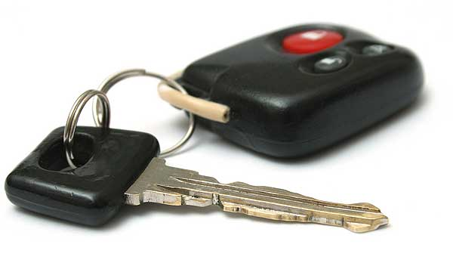
- Tell anything else that pertains to the object that may be of interest to the audience.
- The speech may be either informative or entertaining.
- Time requirement is 1 ½ min. – take or give 15 seconds.

Attention getter ideas: stories, quotes, facts, jokes, etc…
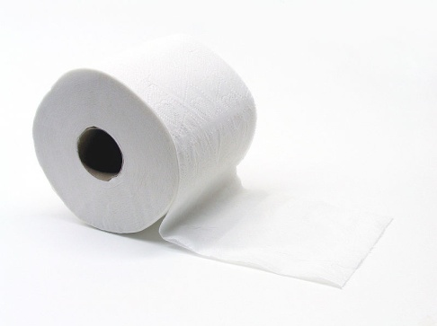
Thesis statement….

Need to write a short outline

** Make sure the attention getter in your introduction and conclusion tie together!

