Parts of a Stage/Theatre Study Guide

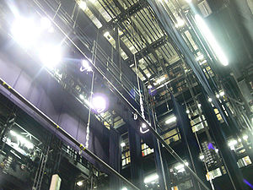
- Fly System - theatrical rigging system, is a system of lines (e.g. ropes), blocks (pulleys), counterweights and related devices within a theater that enables a stage crew to quickly, quietly and safely fly (hoist) components such as curtains, lights, scenery, stage effects and, sometimes, people
- Pin Rail - a rail on a fly gallery, wall, etc., holding two rows of pins for securing lines attached to scenery
- Drop – like a back drop
- Pipe Batten - a long metal pipe suspended above the stage or audience from which lighting fixtures, theatrical scenery, and theater drapes and stage curtains may be hung. Battens that are located above a stage can usually be lowered to the stage
- Footlights - the lights at the front of a stage that are nearly on a level with the feet of the performers.
- Teaser/ Tormentors - placed directly upstage of the structural proscenium opening
- Gridiron - A metal structure high above the stage of a theater, from which ropes or cables are strung to scenery and lights.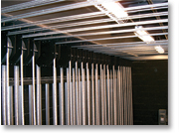
- Curtain Track -
- Batten - a long metal pipe suspended above the stage or audience from which lighting fixtures, theatrical scenery, and theater drapes and stage curtains may be hung. Battens that are located above a stage can usually be lowered to the stage
- Proscenium Arch - A proscenium is the area of a theater surrounding the stage opening. A proscenium arch is the arch over this area.
- Curtain – behind grande drape
- Grande Drape – main, front curtain
- Orchestra Pit – below apron
- Trap Door – usually middle of the stage – set into the floor
- Apron - part of a stage extending in front of the curtain.
- Stage Directions
  - DL, SL, UL
  - DR, SR, UR
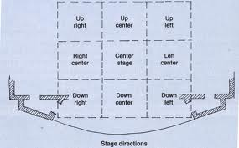
  - DC, C, UC
- Legs - are tall, narrow stage drapes that are used to mask the wings on either side of the stage
- Borders - like teasers/tormentors, but behind them. They are wide, short drapes that span the width of the stage
- Cyclorama - A cyclorama or cyc is a large white curtain, often concave, at the back of the stage that can be lit to represent the sky or other backgrounds.
- Scrim - A scrim, sometimes gauze, is a curtain made of an open-weave fabric that appears opaque when lit from the front, but transparent when a person or object behind the curtain is lit.

