Veteran Photostory
Create a Photostory including all three of your veterans.
For each veteran, you should have at least 3 pictures indicating something about them.
You will be recording your voice and the information included for each veteran is:
- Their name
- Where they are from
- Where and how they served
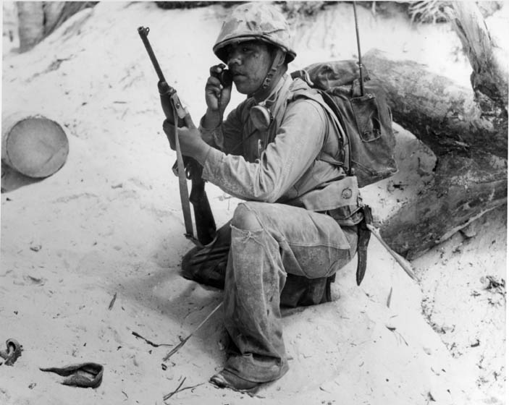
- The most interesting thing about them
- And something else that you find note-worthy
- If it’s not at least 30 seconds in length, it’s not long enough

- You need an introduction slide with your name on it explaining who you are and something about this project – what it is, what we did, etc…
- After your veteran slides, I want you to create another section with 5 facts about WWII that you read about outside of our Blue Stars book. Each fact should have its own picture to go with it.
- The end of your Photostory needs to include 2 pictures and at least 15 seconds of voice recording explaining to your listeners how this unit impacted you in a positive way.
- You must include music in the background that comes from the 1940’s or the WWII era. You can create this at the end of you
- If you prefer to label your pictures and change transitions, that’s fine. Since it’s not a requirement, however, wait until the end to make sure you have enough time to do so.
- Make this something special – something you will be proud to show off at the end!

