Where the Red Fern Grows Project
Choose two of the following projects to complete by the due date.
STORY POLE:
- You will choose at least 5 symbols (pictures) that represent important ideas from the story. Your symbols can either be drawn, come from magazines or newspapers, or the computer.
- You must explain why you chose each symbol. Be very specific. Include important information like:
* character names * setting * background information or details
You must use complete sentences with correct spelling, capitalization,
and punctuation. Your explanation can be handwritten or typed.
- Symbols must be arranged in a logical order.
- Be creative!
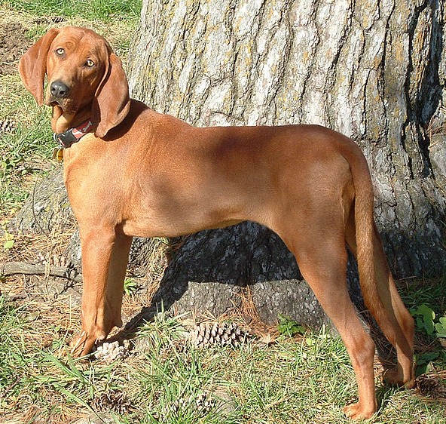
STORY TIMELINE:
- You will put in sequential order at least 5 important events that happened in your book.
2. You should represent each event with a detailed explanation of why this event is important. You should include important information such as:
* When the event happened
* Who was involved?
* How old was the character when the event happened?
* How did the character feel?
* Why is this event important?
3. You must use complete sentences with correct spelling, capitalization, and punctuation. Your explanation can be handwritten or typed. Be creative!
Pictures are optional but would really enhance your project.
STORY MOBILE:
- You will create a mobile using a clothes hanger and yarn (string). You must hang the following information from your mobile:
* Characters: (protagonist, antagonist, other significant (important) characters. Give a brief description of each.
* Setting: Where and when does the story take place?
* Brief summary of the plot of the story: conflict (rising action), climax, and resolution.
* Your favorite part of the book.
2. You must use complete sentences with correct spelling, capitalization, and punctuation. Your information can be handwritten or typed. Be creative! Pictures are optional but would really enhance your project.
STORY JOURNAL:
- Choose a character from the story. Write at least 5 journal entries from that characters viewpoint.
* Tell the significance (importance) of what you are writing about.
* How do you feel?
* What are you thinking?
* Why did you do what you did?
* How might you have changed what happened?
* What are your future plans (after the story ended)?
Be very detailed and specific.
- You must use complete sentences and write your entries in paragraph form. Use correct spelling, capitalization, and punctuation.
- Include dates with your entries. (You may make them up if needed but be realistic according to the time period of the story)
- If your journal is typed you must include a cover page with the characters name and book title on it. You must also include a picture. I will give you protective sheets for your pages and the pages will be attached together.
- If the journal is handwritten (not typed), I will give you a notebook to use as a journal. The front cover will be decorated and have the characters name and book title on it.
RESEARCH:
Produce a multimedia presentation (video, tape recording, Power Point, Photostory) presentation comparing hound dogs and raccoons (must cite your sources)
* Length of gestation (the period of development of the offspring during the pregnancy)
* Number of siblings
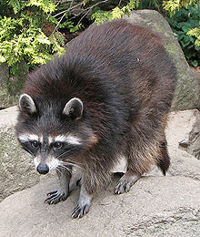
* Birth weight
* Weight at 6 months
* Food
* Enemies
* Habitat-where they live
* Life span
* Cost of hound dogs
* Cost of hides
* Strange and unusual facts???

Grading: This project is worth 100 points – 50 points each. Each day the project is late, 10 points will be deducted from the grade.
Two class periods will be provided as workdays. Computers will be available during those times. You will also need to work on this project out of class.

